Giving Feedback — Do’s and Don’ts
These principles apply whether you’re giving praise or addressing a performance issue
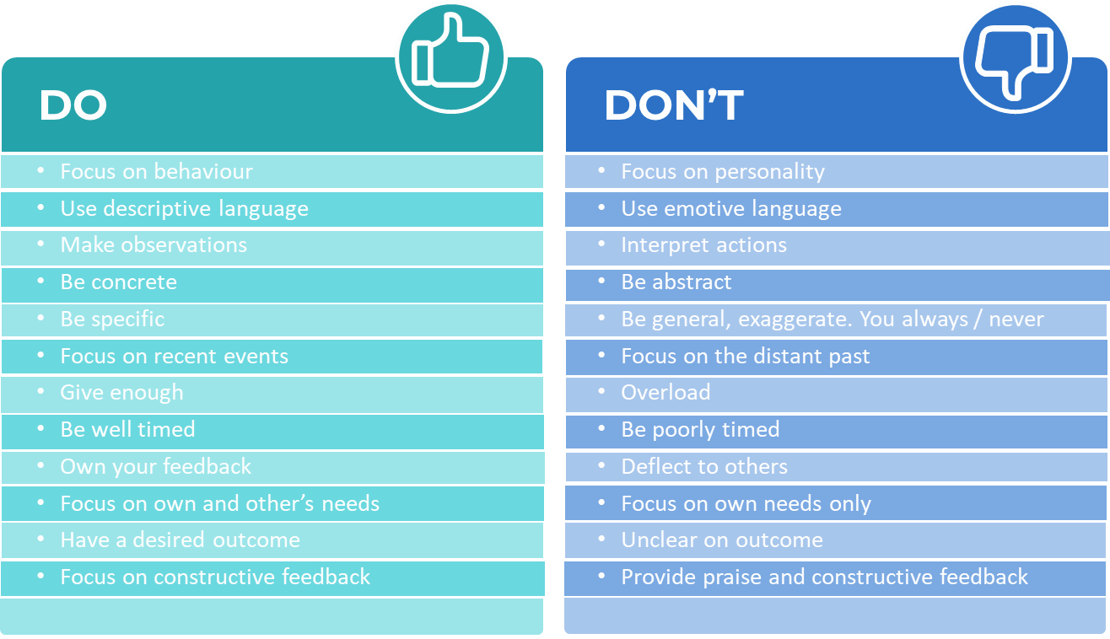

The golden rule for ALL feedback — praise or correction:
Be specific about WHAT they did and WHY it mattered. ‘Great job’ is forgettable. ‘The way you handled that customer complaint yesterday — staying calm and offering a solution on the spot — that’s exactly what we stand for.’ That’s memorable.
• Praise publicly when the behaviour sets the standard you want others to follow, or the person went above and beyond.
• Praise privately when the person is introverted, when the matter is personal, or when you want to build trust one-on-one.

⏱ The 24-hour rule applies to positive feedback too — praise it while it’s fresh, and the person knows exactly what behaviour you’re recognising.

